The calculator should follow these steps:

Step 1: Pick Gate or Screen

Step 2: Select Variations

* Powdercoated - Timber Look - Custom Colour

2.1 Select Colour (each variation has colour options, for example timber look has wood olive, jarrah, wild oak etc)

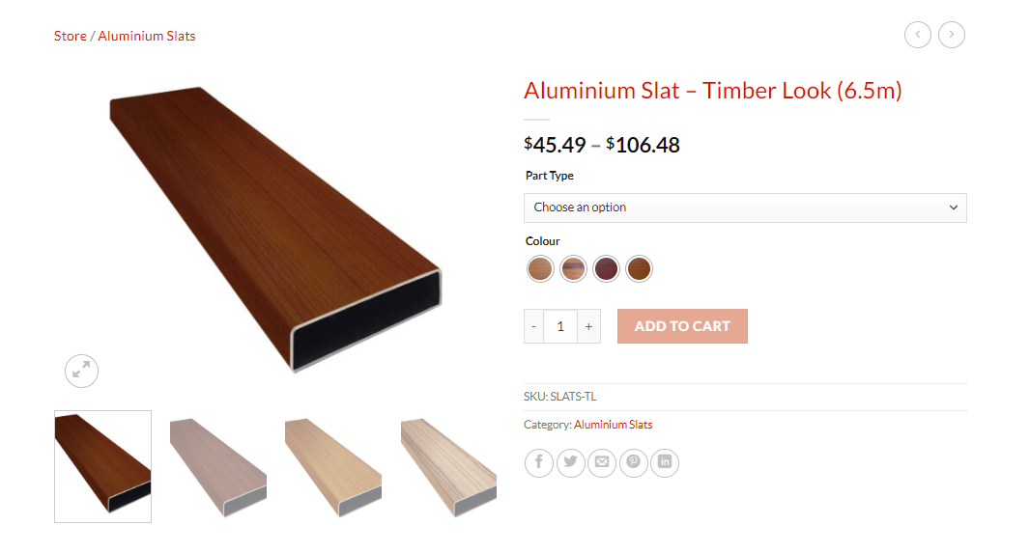

2.2 Select Slat Size (each slat has 3 sizes; 38mm, 65mm & 100mm)

(follow current website)

Step 3: Bay size (allow them to add bays). Add height, Width, Horizontal Gap, Channel Angle (left + right)

See the website for example

Step 4: Customer will see the selection of products suggested for their size, and have the option to add to cart

Products:

|  |  |  |
| --- | --- | --- |
| Aluminium Product list for Gate calculator | | |
| 1 | Aluminium Slat | https://wanneroopatios.com.au/product-category/aluminium-slats/ |
| 2 | Aluminium Channels | https://wanneroopatios.com.au/product/aluminium-channel-custom-colour/ |
| 3 | Gate Frames | https://wanneroopatios.com.au/product/aluminium-gate-frame-custom-colour/ |
| 4 | Channel Covers | https://wanneroopatios.com.au/product-category/covers/ |
| 5 | Lock and latch heavy | https://wanneroopatios.com.au/product/gate-lock-latch-set-70kg/ |
| 6 | Corner stake | https://wanneroopatios.com.au/product/heavy-duty-corner-stakes/ |
| 6 | Hinges | https://wanneroopatios.com.au/product/gate-lock-latch-set-30-kg/ |

*Make sure to add all colour options for the products. If you want I can send each colour option separately if that makes your life easier

**Calculations:**

Points of measure (customer to fill in)

|  |  |  |  |  |
| --- | --- | --- | --- | --- |
| Height | Width | Slat Gap | Slat Size | Length |

Screens

|  |
| --- |
| Products |
| 1. Slats |
| 1. Channels |
| 1. Channel cover |
| 1. End Caps |

*check excel sheet for calculations

Gates

|  |
| --- |
| Products |
| 1. Slats |
| 1. Gate Frames |
| 1. Channel cover |
| 1. Lock & Latch |
| 1. Heavy Duty Hinges |
| 1. Corner Gate Stake |

GATE CALCULATOR

A – SLAT SIZE

B – GAP SIZE

C – GATE WIDTH

D – GATE HEIGHT

E – TOP & BOTTOM FRAME

F – SLAT SIZE + GAP SIZE

G – NUMBER OF SLATS IN GATE

H – WIDTH (MINUS -) SIDE FRAME

I – STANDARD SLAT LENGTH (RETAIL)

K – STANDARD GATE FRAME LENGTH (RETAIL)

M – FULL PREIMETER MEASUREMENT

First calculation (N) – Number of slats

D – 100mm = E

A + B = F

E/F = G (Round Up)

C – 100mm = H

I/H = J

G/J = N

Second Calculation (L) – Gate Frame

(C x 2) + (D x 2) = M

K/M = L (Round UP)

Third Calculations (O) – Channel Cover

O = L

Four & Fifth Calculations

1 Hinge and lock latch per gate

Gates wider than 1500 = 2 Hinges

Sixth Calculation - Corner gate stake

4 per gate

SCREEN CALCULATOR

Calculations for screen are as per timesheet attached.